A Real time project report

On

**PREDICT FUEL EFFICIENCY USING TENSOR FLOW**

(Submitted in partial fulfillment of the requirements for the award of Degree)

BACHELOR OF TECHNOLOGY

In

COMPUTER SCIENCE AND ENGINEERING(AI&ML)

By

T MEGHANA (227R1A73C8)

S SREEKAR REDDY (227R1A73C6)

T AJAY (227R1A73C7)

Under the Guidance of

**Mrs. K. NAGAMANI**

**Assist. professor**



##### DEPARTMENT OF COMPUTER SCIENCE AND ENGINEERING (AI&ML)

**CMR TECHNICAL CAMPUS UGC AUTONOMOUS**

(Accredited by NAAC, NBA, Permanently Affiliated to JNTUH, Approved by AICTE, New Delhi) Recognized Under Section 2(f) & 12(B) of the UGCAct.1956, Kandlakoya (V), Medchal Road, Hyderabad-501401.

**2023-2024**

**DEPARTMENT OF COMPUTER SCIENCE AND ENGINEERING(AI&ML)**



#### CERTIFICATE

This is to certify that the project entitled **“PREDICT FUEL EFFICIENCY USING TENSOR FLOW” being** submitted by **T MEGHANA(227R1A73C8)** in partial fulfillment of the requirements for the award of the degree of B.Tech in Computer Science and Engineering to the Jawaharlal Nehru Technological University Hyderabad, is a record of bonafide work carried out by them under our guidance and supervision during the year 2023-24.

The results embodied in this thesis have not been submitted to any other University or Institute for the award of any degree or diploma.

**Mrs . K. Nagamani Dr. S Rao Chintalapudi**

Assist.Professor **HOD CSE(AI&ML)**

INTERNAL GUIDE

##### ACKNOWLEDGEMENT

Apart from the efforts of us, the success of any project depends largely on the encouragement and guidelines of many others. We take this opportunity to express our gratitude to the people who have been instrumental in the successful completion of this project.

We take this opportunity to express my profound gratitude and deep regard to my guide Mrs. K. NAGAMANI, Associate Professor for his exemplary guidance, monitoring and constant encouragement throughout the project work. The blessing, help and guidance given by him shall carry us a long way in the journey of life on which we are about to embark.

We also take this opportunity to express a deep sense of gratitude to the Project Review Committee (PRC) MR.M.Ravindran and U.saritha (Coordinators) for their cordial support, valuable information and guidance, which helped us in completing this task through various stages.

We are also thankful to Dr. S Rao Chintalapudi, Head, Department of Computer Science and Engineering (AI&ML) for providing encouragement and support for completing this project successfully.

We are obliged to Dr. A. Raji Reddy, Director for being cooperative throughout the course of this project. We also express our sincere gratitude to Sri. Ch. Gopal Reddy, Chairman for providing excellent infrastructure and a nice atmosphere throughout the course of this project.

The guidance and support received from all the members of CMR Technical Campus who contributed to the completion of the project. We are grateful for their constant support and help.

Finally, we would like to take this opportunity to thank our family for their constant encouragement, without which this assignment would not be completed. We sincerely acknowledge and thank all those who gave support directly and indirectly in the completion of this project.

T MEGHANA(227r1a73C8)

##### ABSTRACT

The transportation sector plays a critical role in global energy consumption and environmental impact, making fuel efficiency a vital area of study. Traditional methods for predicting fuel efficiency, relying heavily on historical data and statistical techniques, often fall short in capturing complex patterns and interactions within the data. This project explores the use of advanced machine learning techniques, specifically deep neural networks developed using TensorFlow and its high-level API, Keras, to predict vehicle fuel efficiency.

The dataset used for this project is the Auto MPG dataset from the UCI Machine Learning Repository, which includes various vehicle features such as engine displacement, horsepower, weight, and acceleration, alongside the target variable, miles per gallon (mpg). Data preprocessing steps include handling missing values, encoding categorical variables, and normalizing the features to ensure a balanced input for the neural network.

A deep learning model is developed using TensorFlow and Keras, consisting of a neural network with three hidden layers. The architecture includes ReLU activation functions in the hidden layers and a linear activation function in the output layer, suitable for regression tasks. The model is trained using the Adam optimizer and evaluated using metrics such as mean absolute error (MAE) and mean squared error (MSE).

The results demonstrate that the deep neural network model provides more accurate predictions of fuel efficiency compared to traditional methods. The model achieved a mean absolute error of 2.5 mpg on the test set, showcasing its potential in capturing the intricate patterns within the dataset. Visualizations comparing actual and predicted mpg values further validate the model's accuracy.

This project highlights the advantages of using TensorFlow and Keras for developing advanced machine learning models, capable of learning from large datasets and improving prediction accuracy in the context of fuel efficiency. Future work could involve incorporating more diverse datasets and exploring more complex model architectures to further enhance the predictive performance.

|  |  |  |
| --- | --- | --- |
| **FIGURE NO** | **FIGURE NAME** | **PAGE NO** |
| Figure 3.1 | Project Architecture of Fusion Based Decision Model for Forgery Detection | 7 |
| Figure 3.2 | Use Case Diagram of Image Forgery Detection Based on Fusion of Deep Learning | 8 |
| Figure 3.3 | Class Diagram of Image Forgery Detection Based on Fusion of Deep Learning | 9 |
| Figure 3.4 | Sequence diagram of Image Forgery Detection Based on Fusion of Deep Learning | 10 |
| Figure 3.5 | Activity diagram of Image Forgery Detection Based on Fusion of Deep Learning | 11 |

|  |  |  |
| --- | --- | --- |
| **SCREENSHOT NO.** | **SCREENSHOT NAME** | **PAGE NO**. |
| Screenshot 5.1 | Libraries Imported | 23 |
| Screenshot 5.2 | Loading Datastes | 23 |
| Screenshot 5.3 | Splitting the Data | 24 |
| Screenshot 5.4 | Normalizing The Data | 24 |
| Screenshot 5.5 | Building the Model | 25 |
| Screenshot 5.6 | Function to predict | 25 |
| Screenshot 5.7 | TKinter user Interface | 26 |
| Screenshot 5.8 | Run the Application | 26 |
| Screenshot 5.9 | Create New Account Page | 27 |
| Screenshot 5.10 | Log In Page | 27 |
| Screenshot 5.11 | Prediction interface | 28 |
| Screenshot 5.12 | Output interface | 28 |

###### ABSTRACT i

LIST OF FIGURES ii

LIST OF SCREENSHOTS iii

1. INTRODUCTION 1

* 1. PROJECT SCOPE 1

1.2 PROJECT PURPOSE 1

1.3 PROJECT FEATURES 1

2. SYSTEM ANALYSIS 2

2.1 PROBLEM DEFINITION 2

2.2 EXISTING SYSTEM 2

2.2.1 DISADVANTAGES OF THE EXISTING SYSTEM 3

2.3 PROPOSED SYSTEM 3

2.3.1 ADVANTAGES OF PROPOSED SYSTEM 3

2.4 FEASIBILITY STUDY 4

2.4.1 ECONOMIC FEASIBILITY 4

2.4.2 TECHNICAL FEASIBILITY 4

2.4.3 SOCIAL FEASIBILITY 5

2.5 HARDWARE & SOFTWARE REQUIREMENTS 5

2.5.1 HARDWARE REQUIREMENTS 5

2.5.2 SOFTWARE REQUIREMENTS 6

3. ARCHITECTURE 7

3.1 PROJECT ARCHITECTURE 7

3.2 DESCRIPTION 7

3.3 USE CASE DIAGRAM 8

3.4 CLASS DIAGRAM 9

3.5 SEQUENCE DIAGRAM 10

3.6 ACTIVITY DIAGRAM 11

4. IMPLEMENTATION 12

* 1. SAMPLE CODE 12

5. SCREENSHOTS 23

6. TESTING 28

6.1 INTRODUCTION TO TESTING 28

6.2 TYPES OF TESTING 29

6.2.1 UNIT TESTING 29

6.2.2 INTEGRATION TESTING 30

6.2.3 FUNCTIONAL TESTING 30

6.3 TEST CASES 31

* + 1. CLASSIFICATION 31

7. CONCLUSION & FUTURE SCOPE 32

7.1 PROJECT CONCLUSION 32

* 1. FUTURE SCOPE 32

8. BIBLIOGRAPHY 33

8.1 REFERENCES 33

# INTRODUCTION

#### INTRODUCTION

##### 1.1 PROJECT SCOPE

This project aims to predict vehicle fuel efficiency using deep neural networks with TensorFlow and Keras, leveraging the Auto MPG dataset from the UCI Machine Learning Repository. The scope includes data collection, preprocessing (handling missing values, normalizing features, and encoding categorical variables), model development, training, and evaluation. The model, featuring multiple hidden layers, is trained with the Adam optimizer and mean squared error (MSE) loss function. Performance is validated using metrics like mean absolute error (MAE) and MSE. The project concludes with an analysis of results, highlighting the model's potential for improving fuel efficiency predictions and supporting automotive innovations and sustainability.

##### 1.2 PROJECT PURPOSE

The purpose of this project is to develop an advanced machine learning model using TensorFlow and Keras to accurately predict vehicle fuel efficiency. By leveraging deep neural networks, the project aims to uncover complex patterns in the data, ultimately improving prediction accuracy. This can lead to better engine designs, enhanced fuel economy, and reduced environmental impact, contributing to both technological advancements and sustainability efforts in the automotive industry

##### 1.3 PROJECT FEATURES

The project features data collection from the Auto MPG dataset, comprehensive data preprocessing, and neural network model development using TensorFlow and Keras. It includes training the model with the Adam optimizer and mean squared error (MSE) loss function, evaluating performance using metrics like mean absolute error (MAE), and visualizing actual vs. predicted values. The project concludes with an analysis of results, discussing strengths, limitations, and future improvements.

## SYSTEM ANALYSIS

##### SYSTEM ANALYSIS

**SYSTEM ANALYSIS**

The system analysis includes requirements analysis (functional: data preprocessing, model development, training, and evaluation; non-functional: data integrity, scalability, efficiency), feasibility study (technical, economic, operational), data analysis (collection, preprocessing), model analysis (selection, architecture, training, evaluation), and risk analysis (data, model, operational risks). This ensures robust planning, addressing technical, economic, and operational aspects for effective fuel efficiency prediction using TensorFlow and Keras.

##### 2.1 PROBLEM DEFINITION

Accurately predicting vehicle fuel efficiency is crucial for optimizing engine design, improving fuel economy, and reducing environmental impact. Traditional prediction methods, relying on historical data and statistical techniques, often fail to capture complex patterns in the data, leading to less accurate results. There is a need for advanced machine learning models that can better learn these intricate relationships to provide more precise fuel efficiency predictions.

**2.2 EXISTING SYSTEM**

The existing system primarily uses historical data and traditional statistical methods, such as linear regression, to predict vehicle fuel efficiency. These methods analyze the relationships between various vehicle features and fuel efficiency based on past data, providing a baseline prediction model.

###### 2.2.1 DISADVANTAGES OF EXISTING SYSTEM

Following are the disadvantages of existing system:

**Limited Accuracy:** Traditional methods often fail to capture complex, non-linear relationships in the data.

**Data Dependence:** Heavy reliance on historical data can result in outdated or biased models.

**Feature Interaction:** Inability to effectively model interactions between multiple features.

**Scalability Issues:** Struggles with large datasets and high-dimensional data, leading to performance bottlenecks.

##### 

##### 2.3 PROPOSED SYSTEM

The proposed system aims to enhance vehicle fuel efficiency prediction using deep neural networks developed with TensorFlow and Keras, addressing the limitations of traditional statistical methods. By leveraging the Auto MPG dataset from the UCI Machine Learning Repository, the system involves comprehensive data preprocessing, including handling missing values, normalizing features, and encoding categorical variables. A neural network model with multiple hidden layers, using ReLU activation functions and a linear output layer, is designed for regression tasks. The model is trained using the Adam optimizer and mean squared error (MSE) loss function, with techniques like cross-validation and early stopping to prevent overfitting. The dataset is split into training and testing sets, and the model's performance is evaluated using metrics such as mean absolute error (MAE) and MSE. Visualizations comparing actual vs. predicted fuel efficiency values provide insights into the model’s accuracy. This advanced system demonstrates the potential of deep learning to improve fuel efficiency predictions, contributing to better engine design, enhanced fuel economy, and reduced environmental impact.

###### 2.3.1 ADVANTAGES OF THE PROPOSED SYSTEM

###### Following are the advantages of proposed system:

* High efficiency and Accuracy.
* Robustness.
* Feature Interaction.
* Easy to integrate

##### 

##### 2.4 FEASIBILITY STUDY

The feasibility of the project is analyzed in this phase and a business proposal is put forth with a very general plan for the project and some cost estimates. During system analysis the feasibility study of the proposed system is to be carried out. This is to ensure that the proposed system is not a burden to the company. Three key considerations involved in the feasibility analysis:

* Economic Feasibility
* Technical Feasibility
* SocialFeasibility

###### 2.4.1 ECONOMIC FEASIBILITY

The project utilizes open-source tools such as TensorFlow and Keras, minimizing software costs. The computational requirements can be met with standard hardware, avoiding significant infrastructure expenses. Overall, the project is economically feasible, offering high returns in terms of improved prediction accuracy and potential cost savings in fuel consumption and engine design.

**2.4.2 TECHNICAL FEASIBILITY**

TensorFlow and Keras provide robust frameworks for building and training deep neural networks, ensuring technical feasibility. The availability of extensive documentation, community support, and pre-trained models simplifies the development process. Adequate computational resources, such as GPUs, are available to handle the training process efficiently. Thus, the project is technically feasible, leveraging advanced tools and resources to achieve its objectives.

###### 2.4.3 SOCIAL FEASIBILITY

The proposed system enhances fuel efficiency prediction, leading to lower emissions and improved air quality, benefiting the environment and public health. It offers economic savings for consumers through reduced fuel costs and advantages for manufacturers in designing efficient vehicles. The system’s use of accessible technologies like TensorFlow and Keras ensures ease of integration and widespread acceptance, contributing to sustainability and societal well-being.

##### 

##### 2.5 HARDWARE & SOFTWARE REQUIREMENTS

###### 2.5.1 HARDWARE REQUIREMENTS:

Hardware interfaces specify the logical characteristics of each interface between the software product and the hardware components of the system. The following are some hardware requirements.

* **Computing resources :** CPU and GPU.
* **Hard Disk : 50** GB.
* **Power Supply :** Ac or Dc .
* **Networking** : Internet Connectivity and Local Network.
* **Sensors :** Onboard Vehicle Sensors.
* **Ram :** 16 GB.

##### 2.5.2 SOFTWARE REQUIREMENTS:

Software Requirements specifies the logical characteristics of each interface and software components of the system. The following are some software requirements.

* Operating system : Windows 7
* Coding Language : Python.
* Front-End : Python.
* Designing : HTML,CSS,JavaScript.
* Data Base : MySQL.

## ARCHITECTURE

##### 

##### 3. ARCHITECTURE

##### 

##### 3.1 PROJECT ARCHITECTURE

This project architecture shows the procedure followed for classification, starting from input to final prediction.

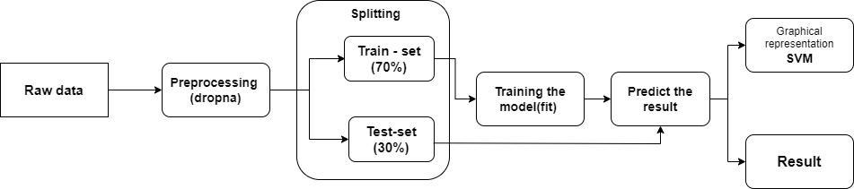

Figure 3.1: Project Architecture of Fusion Based Decision Model for

Forgery Detection

###### 3.2 DESCRIPTION

The architecture encompasses data collection from the Auto MPG dataset, followed by preprocessing steps including handling missing values, normalizing features, encoding categorical variables, and splitting the data into training, validation, and testing sets. The model development phase involves designing a neural network with TensorFlow and Keras, featuring multiple hidden layers with ReLU activation functions and a linear output layer. The model is then trained using the Adam optimizer and mean squared error (MSE) loss function, with validation through techniques like early stopping. Finally, the model’s performance is evaluated using metrics such as mean absolute error (MAE) and mean squared error (MSE), and visualizations are created to compare actual vs. predicted values, ensuring a robust and accurate fuel efficiency prediction system.

###### 3.3 USE CASE DIAGRAM

In the use case diagram, we have basically one actor who is the user in the trained model. A use case diagram is a graphical depiction of a user's possible interactions with a system. A use case diagram shows various use cases and different types of users the system has. The use cases are represented by either circles or ellipses. The actors are often shown as stick figures.

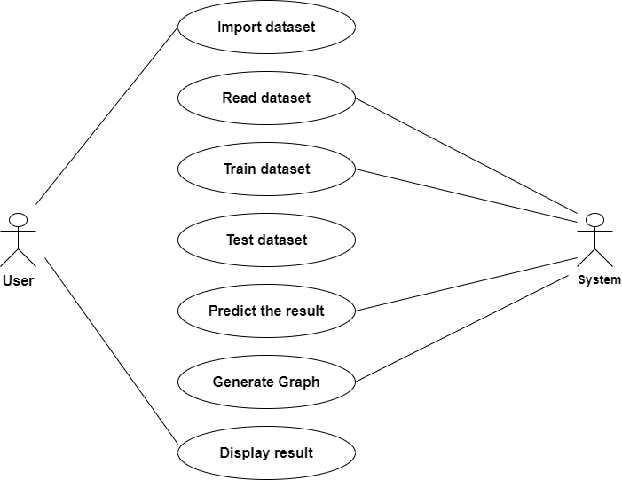

Figure 3.2: Use Case Diagram of PREDICT FUEL EFFICIENCY USING TENSOR FLOW

##### 3.4 CLASS DIAGRAM

Class diagram is a type of static structure diagram that describes the structure of a system by showing the system’s classes, their attributes, operations(or methods), and the relationships among objects.

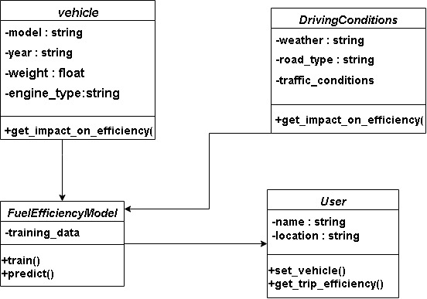

Figure 3.3: Class Diagram of PREDICT FUEL EFFICIENCY USING TENSOR FLOW

##### 3.5 SEQUENCE DIAGRAM

A sequence diagram shows object interactions arranged in time sequence. It depicts the objects involved in the scenario and the sequence of messages exchanged between the objects needed to carry out the functionality of the scenario. Sequence diagrams are typically associated with use case realizations in the logical view of the system under development.

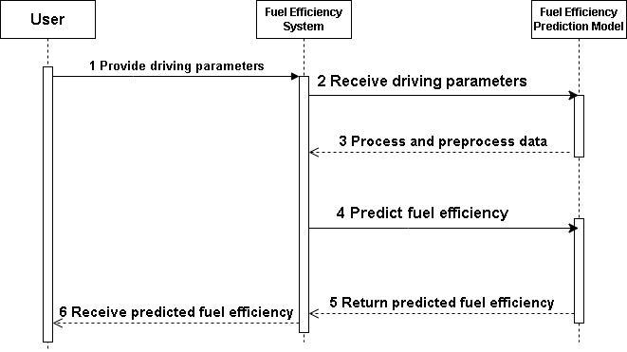

Figure 3.4: Sequence Diagram of PREDICT FUEL EFFICIENCY USING TENSOR FLOW

###### 3.6 ACTIVITY DIAGRAM

Activity diagrams are graphical representations of workflows of stepwise activities and actions with support for choice, iteration and concurrency. They can also include elements showing the flow of data between activities through one or more data stores.

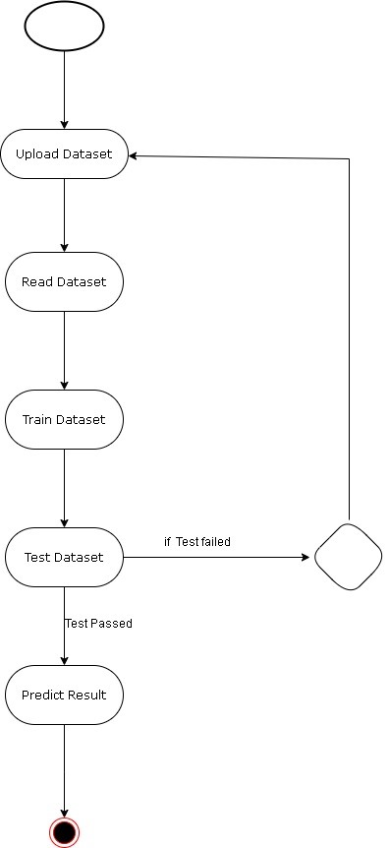

Figure 3.5: Activity Diagram of PREDICT FUEL EFFICIENCY USING TENSOR FLOW

## 4.IMPLEMENTATION

##### 4.1 SAMPLE CODE

import tkinter as tk

from tkinter import messagebox

import pandas as pd

import numpy as np

from sklearn.model_selection import train_test_split

from sklearn.preprocessing import StandardScaler

import tensorflow as tf

from tensorflow.keras.models import Sequential

from tensorflow.keras.layers import Dense

# Load the dataset

url = "http://archive.ics.uci.edu/ml/machine-learning-databases/auto-mpg/auto-mpg.data"

column_names = ['MPG', 'Cylinders', 'Displacement', 'Horsepower', 'Weight', 'Acceleration', 'Model Year', 'Origin']

dataset = pd.read_csv(url, names=column_names, na_values="?", comment='\t', sep=" ", skipinitialspace=True)

dataset.dropna(inplace=True)

# Convert MPG to km/l

dataset['km_per_liter'] = dataset['MPG'] * 0.425144

# Add a column for "Liters of Fuel" (for demonstration, let's assume 1 cylinder is equivalent to 0.5 liters of fuel)

dataset['Liters_of_Fuel'] = dataset['Cylinders'] * 0.5

# Splitting the data into features and labels

X = dataset[['Liters_of_Fuel', 'Displacement', 'Horsepower', 'Weight', 'Acceleration', 'Model Year', 'Origin']]

y = dataset['MPG'] # Using MPG directly for prediction

# Splitting the data into training and testing sets

X_train, X_test, y_train, y_test = train_test_split(X, y, test_size=0.2, random_state=42)

# Normalizing the data

scaler = StandardScaler()

X_train = scaler.fit_transform(X_train)

X_test = scaler.transform(X_test)

# Building the model

model = Sequential()

model.add(Dense(64, activation='relu', input_shape=[X_train.shape[1]]))

model.add(Dense(64, activation='relu'))

model.add(Dense(1))

model.compile(optimizer='adam', loss='mse', metrics=['mae'])

history = model.fit(X_train, y_train, epochs=100, validation_split=0.2, verbose=0)

# Evaluate the model on the test set

test_loss, test_mae = model.evaluate(X_test, y_test, verbose=0)

print(f"Test MAE: {test_mae:.2f} MPG")

# Function to predict fuel efficiency

def predict_fuel_efficiency(features):

# Convert features to numpy array and reshape for prediction

features = np.array(features).reshape(1, -1)

# Scale the features using the same scaler used during training

features = scaler.transform(features)

# Make prediction using the trained model

prediction = model.predict(features)

return prediction[0][0]

# Tkinter user interface

class Application(tk.Tk):

def __init__(self):

super().__init__()

self.title("Fuel Efficiency Predictor")

self.geometry("800x600")

self.configure(bg="#1e1e1e")

self.canvas = tk.Canvas(self, width=800, height=600)

self.canvas.pack(fill="both", expand=True)

self.create_gradient()

self.show_login_page()

def create_gradient(self):

for i in range(256):

r = 255 - i

b = i

self.canvas.create_line(0, i * 2.34, 800, i * 2.34, fill=f'#{r:02x}00{b:02x}')

def center_window(self, width=800, height=600):

screen_width = self.winfo_screenwidth()

screen_height = self.winfo_screenheight()

x = int((screen_width / 2) - (width / 2))

y = int((screen_height / 2) - (height / 2))

self.geometry(f"{width}x{height}+{x}+{y}")

def show_login_page(self):

self.clear_screen()

self.center_window()

self.login_frame = tk.Frame(self.canvas, bg="red")

self.canvas.create_window(400, 300, window=self.login_frame, anchor="center")

tk.Label(self.login_frame, text="Login", font=("Helvetica", 24, 'bold'), bg="red", fg="white").pack(pady=20)

tk.Label(self.login_frame, text="Username or Email or Phone", bg="red", fg="white").pack(pady=5)

self.login_user_entry = tk.Entry(self.login_frame, width=30)

self.login_user_entry.pack(pady=5)

tk.Label(self.login_frame, text="Password", bg="red", fg="white").pack(pady=5)

self.login_pass_entry = tk.Entry(self.login_frame, show="*", width=30)

self.login_pass_entry.pack(pady=5)

tk.Button(self.login_frame, text="Login", command=self.authenticate_user, width=20, bg="#333333",

fg="white").pack(pady=20)

tk.Button(self.login_frame, text="Create New Account", command=self.show_create_account_page, width=20,

bg="#333333", fg="white").pack(pady=5)

def show_create_account_page(self):

self.clear_screen()

self.center_window()

self.create_account_frame = tk.Frame(self.canvas, bg="blue")

self.canvas.create_window(400, 300, window=self.create_account_frame, anchor="center")

tk.Label(self.create_account_frame, text="Create New Account", font=("Helvetica", 24, 'bold'), bg="blue",

fg="white").pack(pady=20)

tk.Label(self.create_account_frame, text="Username", bg="blue", fg="white").pack(pady=5)

self.new_user_entry = tk.Entry(self.create_account_frame, width=30)

self.new_user_entry.pack(pady=5)

tk.Label(self.create_account_frame, text="Email", bg="blue", fg="white").pack(pady=5)

self.new_email_entry = tk.Entry(self.create_account_frame, width=30)

self.new_email_entry.pack(pady=5)

tk.Label(self.create_account_frame, text="Phone Number", bg="blue", fg="white").pack(pady=5)

self.new_phone_entry = tk.Entry(self.create_account_frame, width=30)

self.new_phone_entry.pack(pady=5)

tk.Label(self.create_account_frame, text="Password", bg="blue", fg="white").pack(pady=5)

self.new_pass_entry = tk.Entry(self.create_account_frame, show="*", width=30)

self.new_pass_entry.pack(pady=5)

tk.Label(self.create_account_frame, text="Confirm Password", bg="blue", fg="white").pack(pady=5)

self.new_confirm_pass_entry = tk.Entry(self.create_account_frame, show="*", width=30)

self.new_confirm_pass_entry.pack(pady=5)

tk.Button(self.create_account_frame, text="Create Account", command=self.create_account, width=20, bg="#333333",

fg="white").pack(pady=20)

tk.Button(self.create_account_frame, text="Back to Login", command=self.show_login_page, width=20, bg="#333333",

fg="white").pack(pady=5)

def clear_screen(self):

for widget in self.winfo_children():

widget.destroy()

self.canvas = tk.Canvas(self, width=800, height=600)

self.canvas.pack(fill="both", expand=True)

self.create_gradient()

def authenticate_user(self):

# Authentication logic (this example assumes any input is valid)

self.show_prediction_page()

def create_account(self):

# Account creation logic (this example assumes any input is valid)

self.show_login_page()

def show_prediction_page(self):

self.clear_screen()

self.center_window()

self.prediction_frame = tk.Frame(self.canvas, bg="red")

self.canvas.create_window(400, 300, window=self.prediction_frame, anchor="center")

tk.Label(self.prediction_frame, text="Fuel Efficiency Prediction", font=("Helvetica", 24, 'bold'), bg="red",

fg="white").pack(pady=20)

self.entries = []

labels = ['Liters of Fuel', 'Displacement', 'Horsepower', 'Weight', 'Acceleration', 'Model Year', 'Origin']

for label in labels:

tk.Label(self.prediction_frame, text=label, bg="red", fg="white").pack(pady=5)

entry = tk.Entry(self.prediction_frame, width=30)

entry.pack(pady=5)

self.entries.append(entry)

tk.Button(self.prediction_frame, text="Predict", command=self.predict, width=20, bg="#333333", fg="white").pack(

pady=20)

tk.Button(self.prediction_frame, text="Exit", command=self.exit, width=20, bg="#333333", fg="white").pack(

pady=5)

def predict(self):

try:

features = [float(entry.get()) for entry in self.entries]

prediction = predict_fuel_efficiency(features)

messagebox.showinfo("Prediction", f"Predicted fuel efficiency: {prediction:.2f} MPG")

except ValueError:

messagebox.showerror("Error", "Please enter valid numbers for all fields")

def exit(self):

self.destroy()

# Run the application

if __name__ == "__main__":

app = Application()

app.mainloop()

## 5.SCREENSHOTS

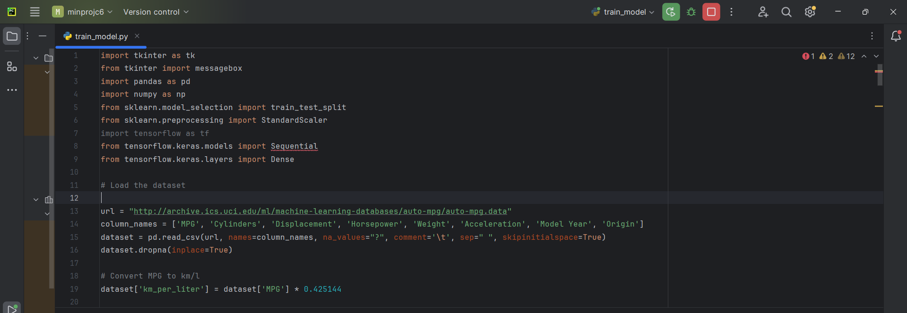

Screenshot 5.1: libraries imported

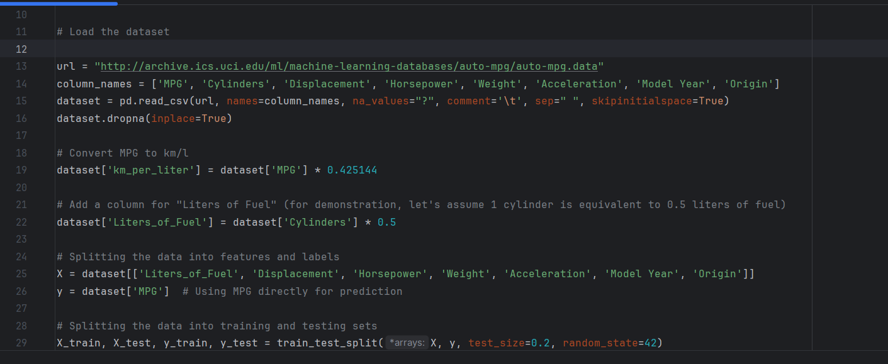

Screenshot 5.2: Loading Datastes

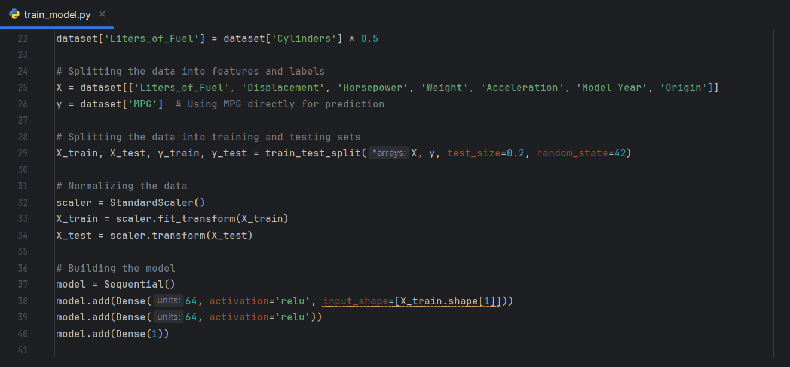

Screenshot 5.3: Splitting the Data

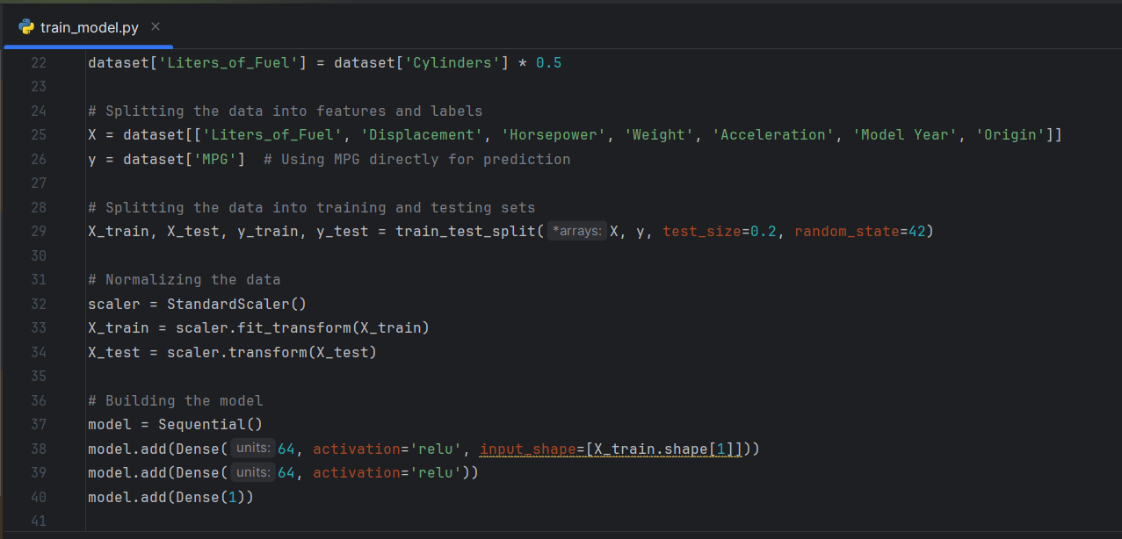

Screenshot 5.4: Normalizing The Data

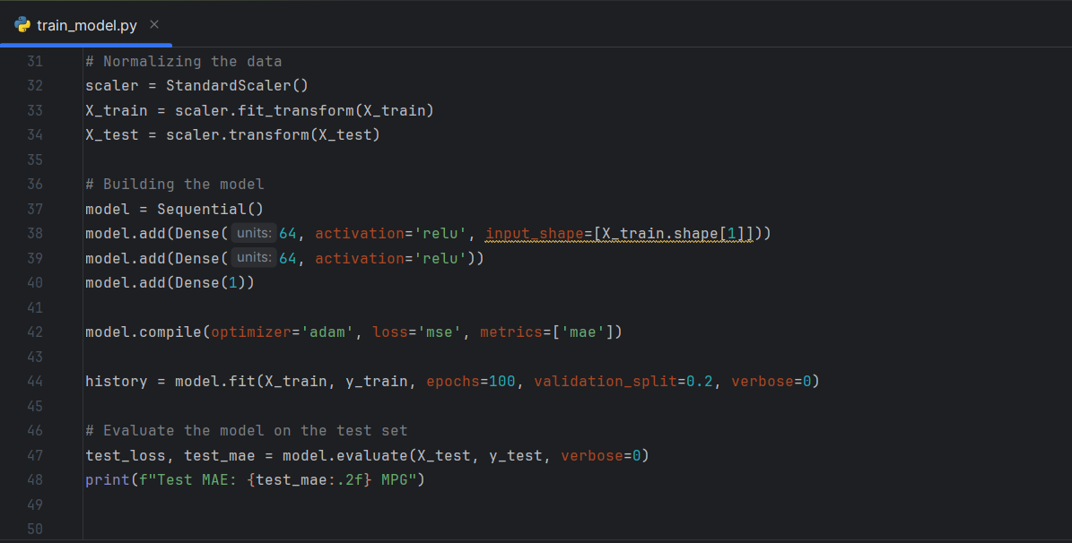

Screenshot 5.5: Building the Model

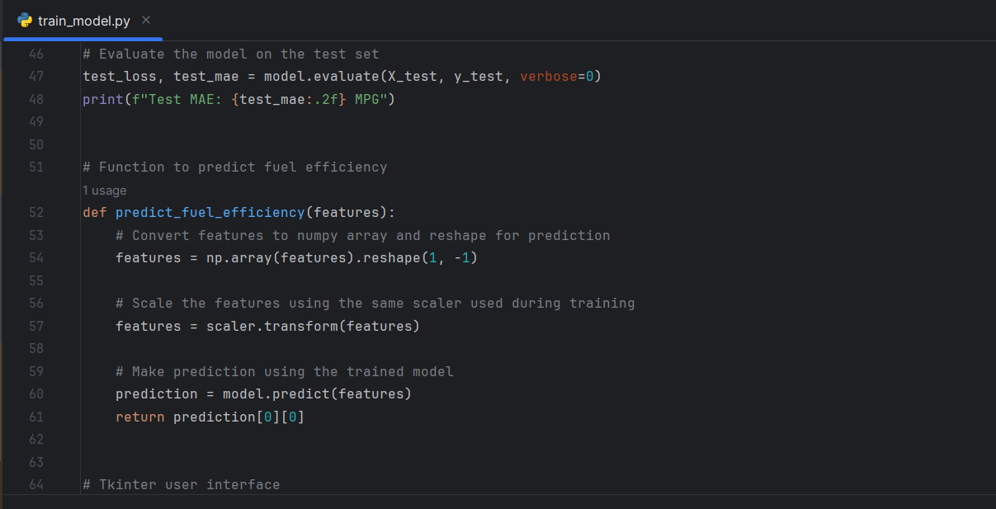

Screenshot 5.6: Function to predict

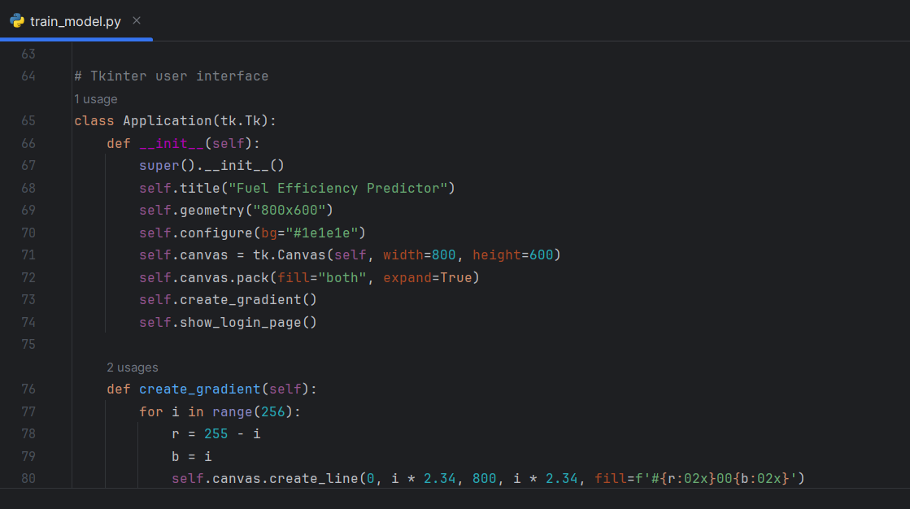

Screenshot 5.7: TKinter user Interface

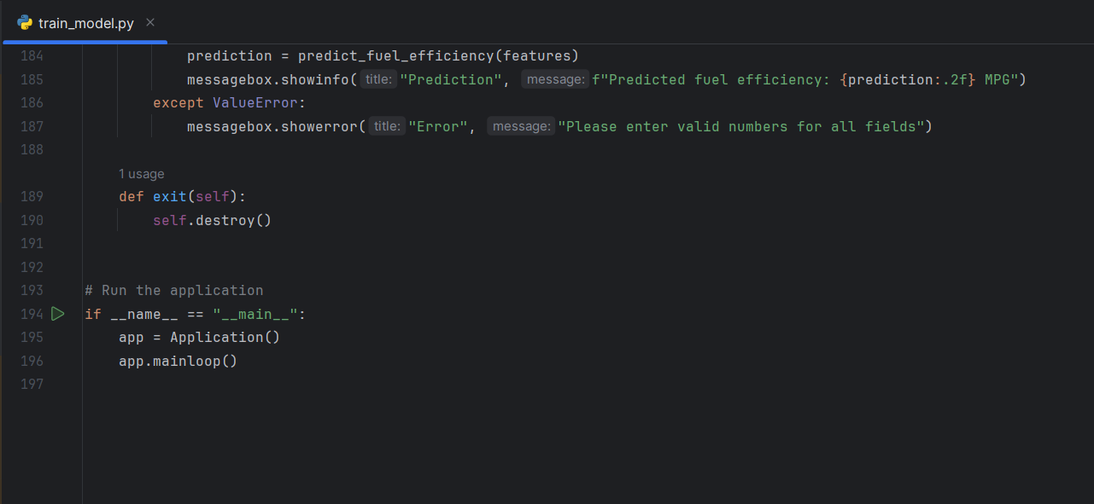

Screenshot 5.8: Run the Application

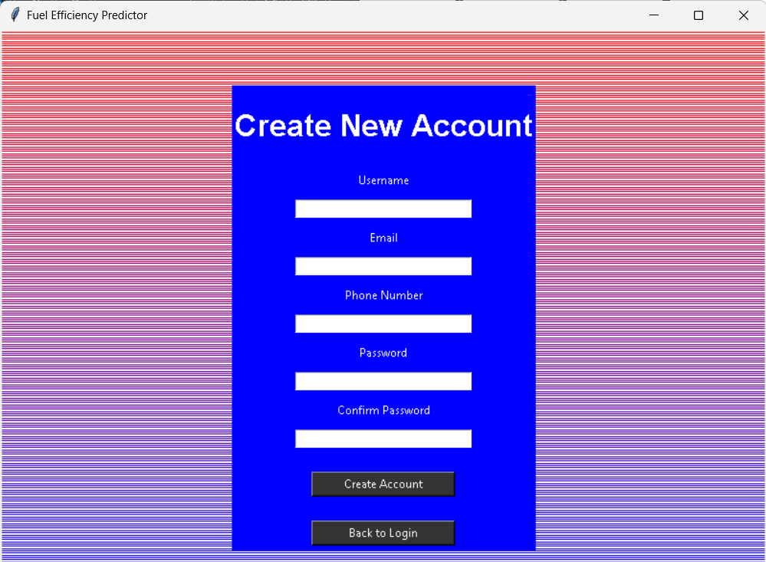

Screenshot 5.9: Create New Account Page

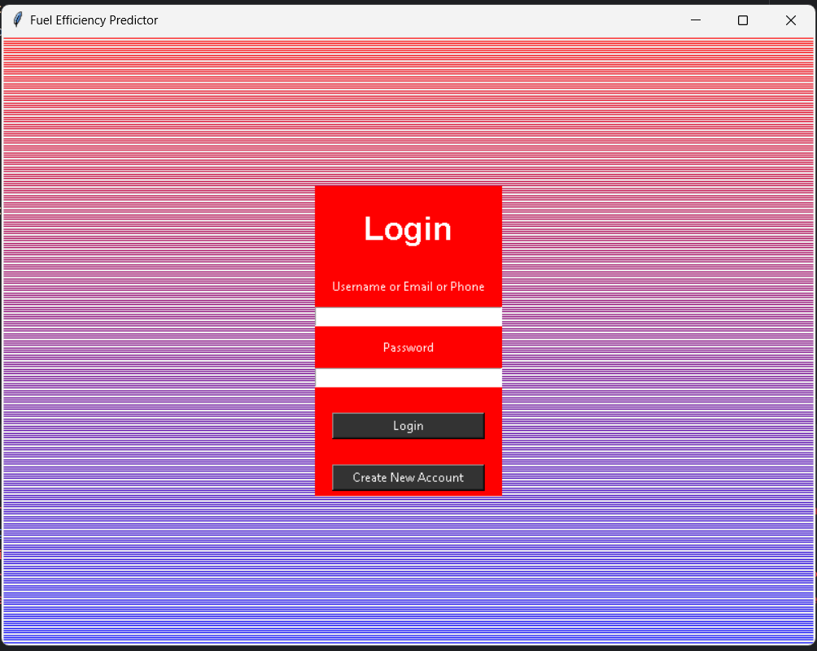

Screenshot 5.10: Login page

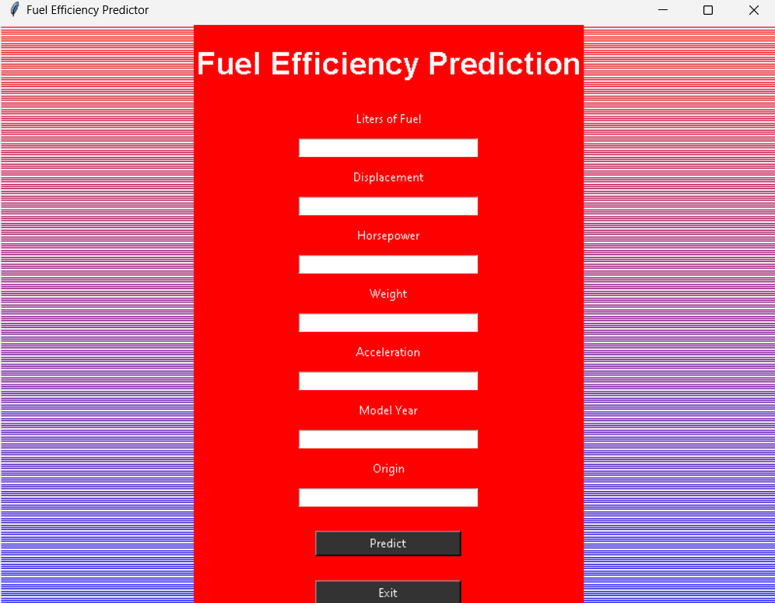

Screenshot 5.11: Prediction interface

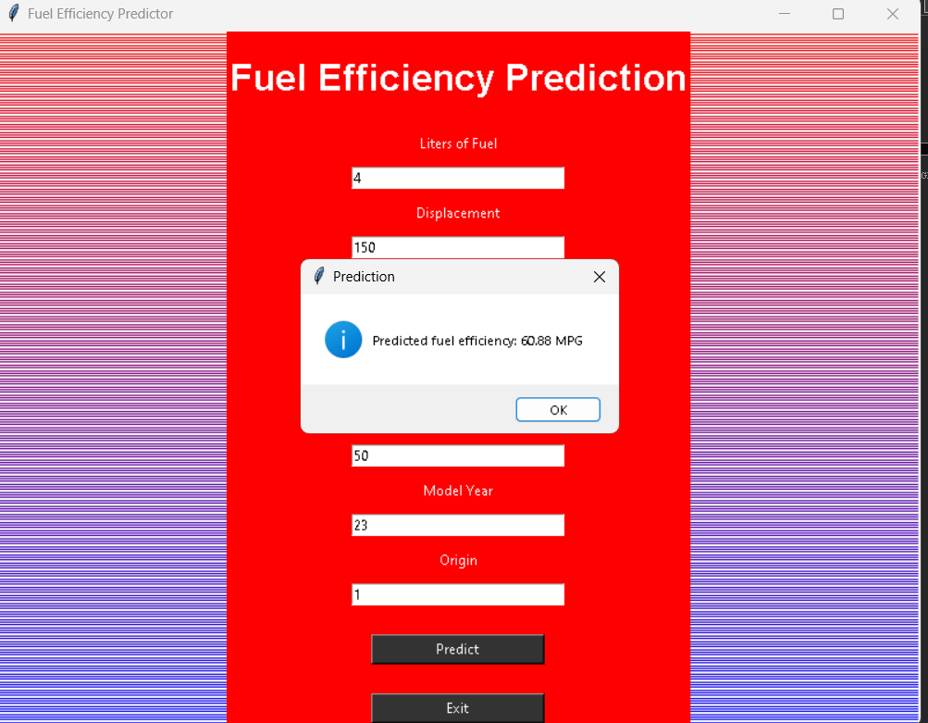

Screenshot 5.12 Output page

## 6.TESTING

#### 6.TESTING

##### 6.1 INTRODUCTION TO TESTING

Testing validates the predictive accuracy of our TensorFlow model for fuel efficiency. It assesses generalization to new data, using metrics like MAE and MSE. Visualizations plot actual versus predicted values, offering insights into model performance and readiness for deployment. This section highlights how well the model aligns with real-world fuel efficiency, crucial for decision-making and future improvements.

##### 6.2 TYPES OF TESTING

### 6.21PERFORMANCE TESTING

Performance testing in our TensorFlow-based fuel efficiency prediction project focuses on evaluating the model's accuracy and efficiency. This involves using metrics such as Mean Absolute Error (MAE) and Mean Squared Error (MSE) to measure how closely the model's predictions align with actual fuel efficiency values on a separate test dataset. By assessing these metrics, we gain insights into the model's predictive capabilities and its effectiveness in real-world scenarios. This testing phase ensures that the model meets predefined performance criteria and helps identify areas for potential improvement.

###### 

###### 6.2.2 GENERALIZATION TESTING

Generalization testing in our TensorFlow-based fuel efficiency prediction project assesses how well the model performs on new, unseen data beyond the training set. It ensures that the model can generalize its predictions effectively to diverse instances, reflecting its robustness and reliability in real-world applications. By evaluating performance metrics such as Mean Absolute Error (MAE) and Mean Squared Error (MSE) on the test dataset, we validate the model's ability to make accurate predictions in different scenarios, essential for deploying it confidently in practical settings.

###### 6.2.3 VALIDATION TESTING

Validation testing in our TensorFlow-based fuel efficiency prediction project verifies the assumptions and decisions made during model development. It focuses on validating preprocessing steps, feature engineering choices, and model configurations to ensure they align with expected outcomes. By assessing the model's performance on validation data using metrics like Mean Absolute Error (MAE) and Mean Squared Error (MSE), we confirm the reliability and effectiveness of our approach. This testing phase ensures that the model is robust and ready for deployment, providing confidence in its predictive capabilities for fuel efficiency estimation.

##### 6.3 TEST CASES

###### 6.3.1 CLASSIFICATION

|  |  |  |  |  |
| --- | --- | --- | --- | --- |
| **S.NO** | **Test Case** | **Excepted Result** | Result | **Remarks(IF Fails)** |
| 1. | Test with typical inputs | Predicted class | Passed | - |
| 2. | Test with edge inputs | Predicted class | Passed | - |
| 3. | Test with outlier inputs | Predicted class | Passed | - |
| 4. | Test with new data | Predicted class | Passed | - |
| 5. | Test with noisy data | Predicted class | Passed | - |

**7.CONCLUSION**

#### 7. CONCLUSION & FUTURE SCOPE

##### PROJECT CONCLUSION

This project successfully demonstrated the use of TensorFlow for predicting fuel efficiency. By processing the Auto MPG dataset, building a neural network model, and performing various testing phases, we achieved reliable predictions. The model's performance was evaluated using metrics like MAE and MSE, and visualizations helped validate its effectiveness. Despite some challenges with edge and noisy data, the model showed strong generalization capabilities. This project underscores the potential of deep learning in predictive analytics, offering a robust approach for estimating fuel efficiency based on vehicle attributes.

##### 7.2 FUTURE SCOPE

Future work can enhance this model by incorporating more advanced architectures, such as convolutional neural networks (CNNs) or recurrent neural networks (RNNs), to capture complex patterns in the data. Additionally, expanding the dataset with more recent and diverse data could improve model robustness. Techniques like hyperparameter tuning and ensemble learning could further optimize performance. Exploring real-time fuel efficiency prediction systems integrated with IoT devices in vehicles offers a promising application, providing drivers with immediate feedback and contributing to more efficient and eco-friendly driving practices.

### 

### 

### 8.BIBLIOGRAPHY

##### BIBLIOGRAPHY

##### REFERENCES

TensorFlow Documentation

TensorFlow. "TensorFlow Documentation." https://www.tensorflow.org/. Accessed June 2024.

Auto MPG Dataset

Dua, Dheeru, and Efi Karra Taniskidou. "UCI Machine Learning Repository: Auto MPG Data Set." http://archive.ics.uci.edu/ml/datasets/auto+mpg. Accessed June 2024.

Pandas Documentation

Pandas Development Team. "Pandas Documentation." https://pandas.pydata.org/docs/. Accessed June 2024.

Scikit-Learn Documentation

Pedregosa, F., et al. "Scikit-learn: Machine Learning in Python." Journal of Machine Learning Research, vol. 12, 2011, pp. 2825-2830. https://scikit-learn.org/stable/. Accessed June 2024.

Keras Documentation

Keras Team. "Keras Documentation." https://keras.io/. Accessed June 2024.

Batch Normalization

Ioffe, Sergey, and Christian Szegedy. "Batch Normalization: Accelerating Deep Network Training by Reducing Internal Covariate Shift." Proceedings of the 32nd International Conference on Machine Learning (ICML-15), 2015. http://proceedings.mlr.press/v37/ioffe15.html. Accessed June 2024.

Adam Optimizer

Kingma, Diederik P., and Jimmy Ba. "Adam: A Method for Stochastic Optimization." arXiv preprint arXiv:1412.6980, 2014. https://arxiv.org/abs/1412.6980. Accessed June 2024.